| **BLOG-BYTE Progress File-6** |
| --- |

# **Categories API**

1. **Category schema routes and controllers**
2. **Error handler to avoid duplicates**
3. **Category list read delete**

**_______________________________________________________**

# **TASK-1**

# **Category schema routes and controllers**

**STEPS :**

* In **backend,** go to **models** add **category.js**.
* Creating Category Schema.
* 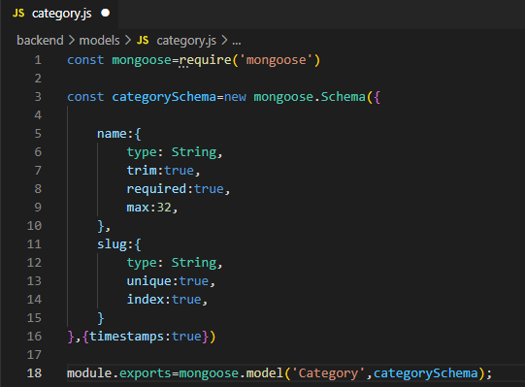
* Now go to **validators** add **category.js**. Create validators here.
* 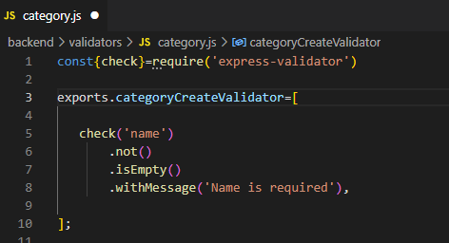
* Now go to **routes** add **category.js**. Create routes here.
* 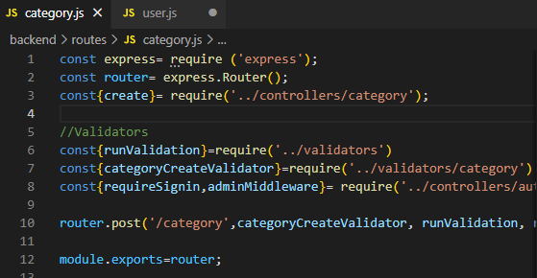
* Only admin can create a new category.
* Adding routes in **server.js.**
* 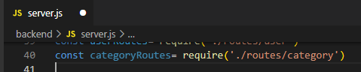
* Applying routes.
* 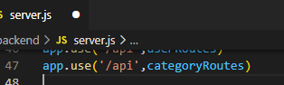
* Now go to **controllers** add **category.js**. Create controllers here.
* 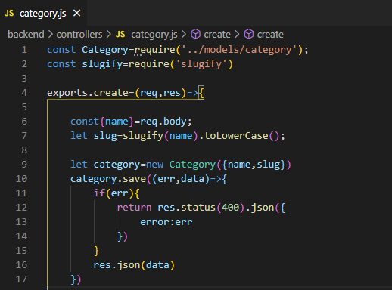
* Now go to postman and give it a try.
* Make sure user is logged in and has role of admin.(also check if token is still valid)

|  |
| --- |

* Category created.
* If user is not admin, we will get error.

|  |
| --- |

* If we try creating same category again, we will get error.Because category should be unique

|  |
| --- |

**=>Category created, Task Completed… :)**

# **TASK-2**

# **Error handler to avoid duplicates**

**STEPS :**

* In **backend** create a folder named **helpers**, inside it create a new file **dbErrorHandler.js**.
* 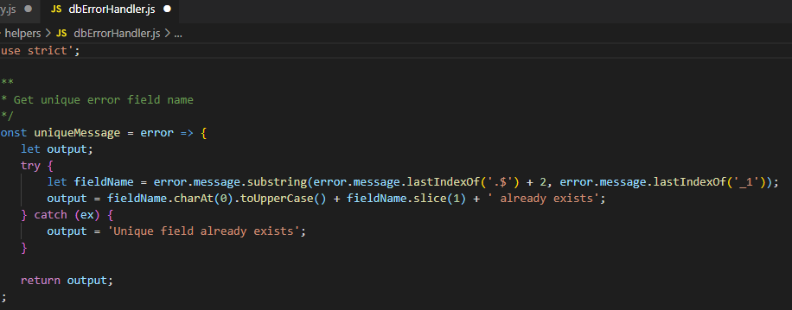
* 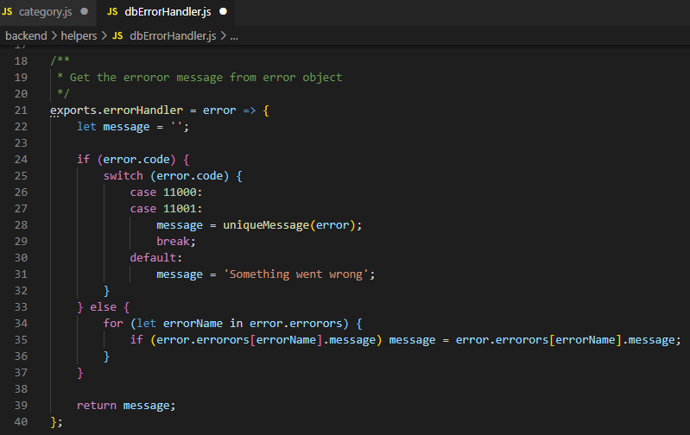
* Now adding it in **category.js** in **controllers**.
* 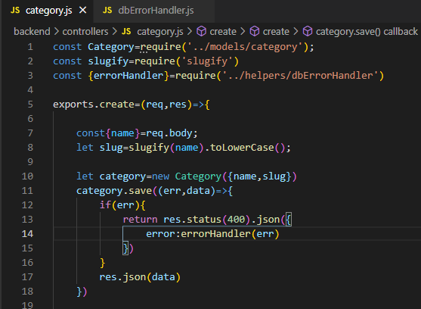
* Now try creating same category , and we will get error message properly.

|  |
| --- |

**=>Error handler added to avoid duplicates categories, Task Completed… :)**

# **TASK-3 Category list read delete**

**STEPS :**

* In **backend** go to **routes**, create more routes in **catogory.js**.
* All categories list, single category and delete category.
* 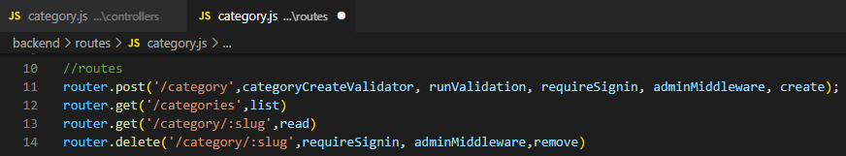
* Import methods.
* 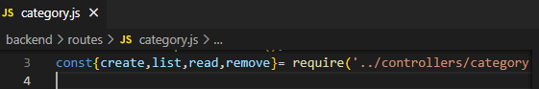
* Now got to **controllers**, create methods in **catogory.js**.
* 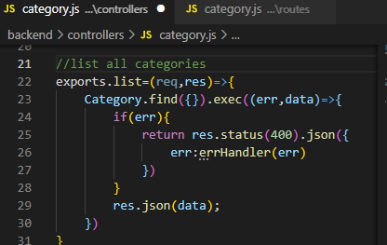
* 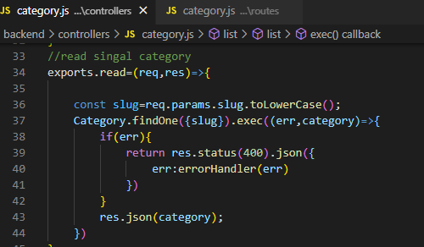
* 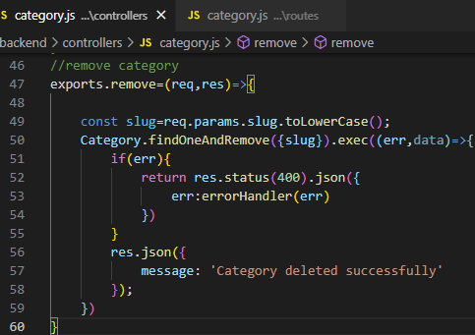
* Now try it on postman, make sure you are signin as admin.
* Create a new category. [http://localhost:8000/api/categor](http://localhost:8000/api/categories)y

|  |
| --- |

* Create category with space in it and see it will be automatically slugified with dash in it..

|  |
| --- |

* Now try getting all categories. <http://localhost:8000/api/categories>

|  |
| --- |

* Now try to get a single category using slug in URL. <http://localhost:8000/api/category/cat-three> .

|  |
| --- |

* Now make a DELETE request to delete category.

|  |
| --- |

* Now checking it deleted category exists, we will get null.

|  |
| --- |

Categories created in database.

|  |
| --- |

**=>Category list, read ,delete ADDED, Task Completed… :)**